Closed Polyline
# Source: AI Source: Provided by: [Data Path: Persons Table -> ID Column: 1, Name_En Column: Motasem Essam] -> From: [ChatGPT] on [7/25/2026]
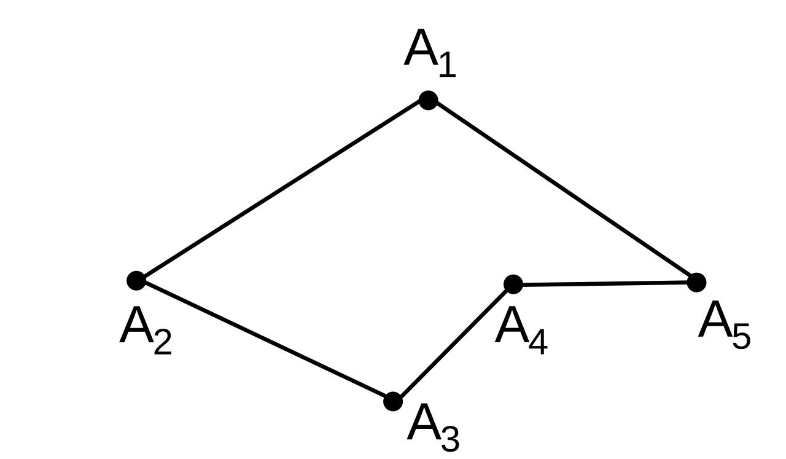
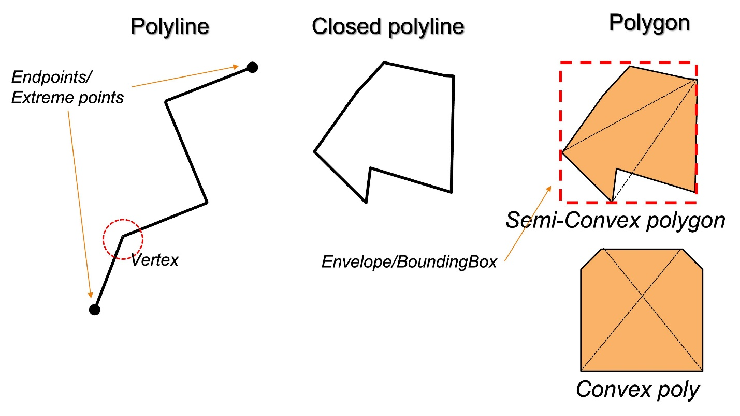
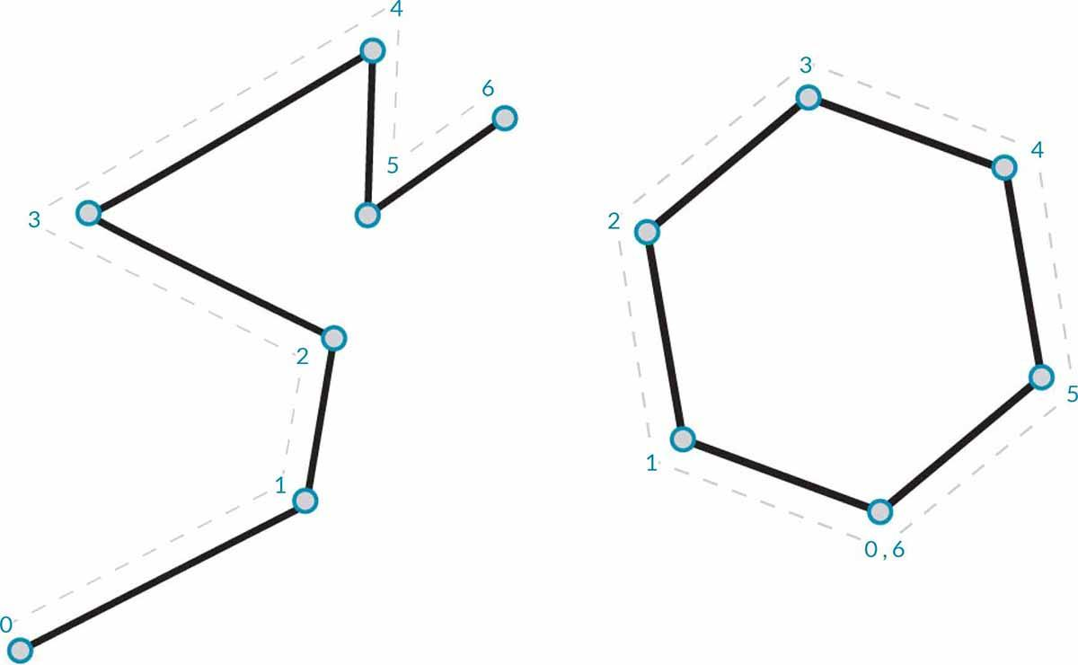
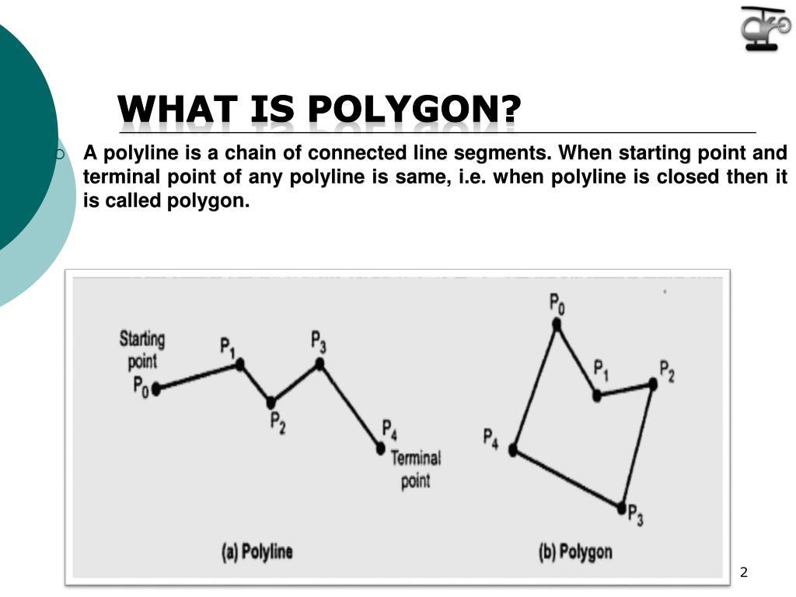

Definition
# Source: AI Source: Provided by: [Data Path: Persons Table -> ID Column: 1, Name_En Column: Motasem Essam] -> From: [ChatGPT] on [7/25/2026]
A Closed Polyline is a polyline whose first and last vertices coincide, forming a continuous closed loop. It is created by connecting a sequence of straight line segments end to end until the final segment returns to the starting point.
A closed polyline encloses a region and serves as the boundary of a polygon.

Characteristics
# Source: AI Source: Provided by: [Data Path: Persons Table -> ID Column: 1, Name_En Column: Motasem Essam] -> From: [ChatGPT] on [7/25/2026]
A closed polyline:
- Consists of two or more connected straight line segments.
- Forms a complete loop.
- Has no open ends.
- Encloses a bounded region.
- Has measurable total length (its perimeter).
- May be regular or irregular.
- Contains infinitely many points along its boundary.

Illustration
# Source: AI Source: Provided by: [Data Path: Persons Table -> ID Column: 1, Name_En Column: Motasem Essam] -> From: [ChatGPT] on [7/25/2026]
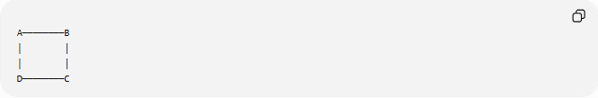
A────────B
│ │
│ │
D────────C
The last segment returns to the starting point, creating a closed polyline.

Components
# Source: AI Source: Provided by: [Data Path: Persons Table -> ID Column: 1, Name_En Column: Motasem Essam] -> From: [ChatGPT] on [7/25/2026]
A closed polyline consists of:
- Vertices
- Straight line segments
- A closed path
Example:
Vertices:
$$A,B,C,D,A$$
Segments:
$$\overline{AB} \\ \overline{BC} \\ \overline{CD} \\ \overline{DA}$$

Mathematical Representation
# Source: AI Source: Provided by: [Data Path: Persons Table -> ID Column: 1, Name_En Column: Motasem Essam] -> From: [ChatGPT] on [7/25/2026]
A closed polyline is represented as an ordered sequence of vertices:
$$P_{1},P_{2},P_{3},…,P_{n},P_{1}$$
where
$$P_{1}=P_{n}$$
The last segment connects the final vertex back to the first.

Perimeter of a Closed Polyline
# Source: AI Source: Provided by: [Data Path: Persons Table -> ID Column: 1, Name_En Column: Motasem Essam] -> From: [ChatGPT] on [7/25/2026]
The total length of a closed polyline is called its perimeter.
If the side lengths are:
$$L_{1},L_{2},…,L_{n}$$
then
$$P=L_{1}+L_{2}+⋯+L_{n}$$

Examples
# Source: AI Source: Provided by: [Data Path: Persons Table -> ID Column: 1, Name_En Column: Motasem Essam] -> From: [ChatGPT] on [7/25/2026]
Example 1 – Rectangle
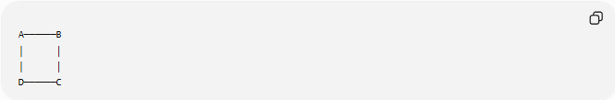
A──────B
│ │
│ │
D──────C
The boundary forms a closed polyline.

Example 2 – Triangle
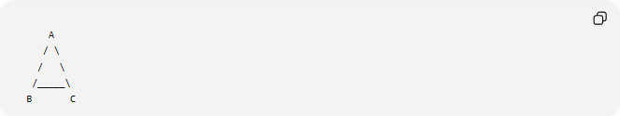
A
/ \
/ \
/_____\
B C
Three connected segments form a closed polyline.

Example 3 – Pentagon
A pentagon is formed by five connected segments that return to the starting point.

Properties
# Source: AI Source: Provided by: [Data Path: Persons Table -> ID Column: 1, Name_En Column: Motasem Essam] -> From: [ChatGPT] on [7/25/2026]
1. Forms a Closed Loop
The path always returns to its starting point.

2. Encloses a Region
Unlike an open polyline, a closed polyline surrounds an interior region.

3. Polygon Boundary
Every polygon boundary is a closed polyline.

4. No Open Ends
Every endpoint is shared by exactly two segments.

Real-World Examples
# Source: AI Source: Provided by: [Data Path: Persons Table -> ID Column: 1, Name_En Column: Motasem Essam] -> From: [ChatGPT] on [7/25/2026]
Closed polylines appear in:
- Building outlines.
- Property boundaries.
- Football fields.
- Swimming pools (polygonal).
- Parking lots.
- Floor plans.
- Land parcels.
- Room layouts.
- Survey maps.
- Computer-generated polygons.

Applications
# Source: AI Source: Provided by: [Data Path: Persons Table -> ID Column: 1, Name_En Column: Motasem Essam] -> From: [ChatGPT] on [7/25/2026]
Closed polylines are used in:
- Plane Geometry
- Coordinate Geometry
- Analytic Geometry
- Engineering
- Architecture
- Surveying
- GIS (Geographic Information Systems)
- CAD (Computer-Aided Design)
- Computer Graphics
- Robotics

Advantages
# Source: AI Source: Provided by: [Data Path: Persons Table -> ID Column: 1, Name_En Column: Motasem Essam] -> From: [ChatGPT] on [7/25/2026]
Studying closed polylines helps to:
- Define polygons.
- Compute perimeter.
- Enclose regions.
- Compute area.
- Model engineering structures.
- Represent boundaries in mapping and design.

Limitations
# Source: AI Source: Provided by: [Data Path: Persons Table -> ID Column: 1, Name_En Column: Motasem Essam] -> From: [ChatGPT] on [7/25/2026]
A closed polyline:
- Uses only straight segments.
- Cannot exactly represent smooth curved shapes.
- May require many short segments to approximate curves.

Comparison with Other Polyline Types
# Source: AI Source: Provided by: [Data Path: Persons Table -> ID Column: 1, Name_En Column: Motasem Essam] -> From: [ChatGPT] on [7/25/2026]
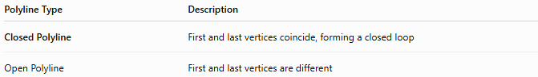
Polyline Type | Description
Closed Polyline | First and last vertices coincide, forming a closed loop
Open Polyline | First and last vertices are different

Key Points
# Source: AI Source: Provided by: [Data Path: Persons Table -> ID Column: 1, Name_En Column: Motasem Essam] -> From: [ChatGPT] on [7/25/2026]
- A Closed Polyline is a connected sequence of straight line segments that forms a complete loop.
- The first and last vertices are the same.
- It encloses a bounded region.
- Its total length is the perimeter.
- Every polygon boundary is a closed polyline.

Conclusion
# Source: AI Source: Provided by: [Data Path: Persons Table -> ID Column: 1, Name_En Column: Motasem Essam] -> From: [ChatGPT] on [7/25/2026]
A Closed Polyline is a continuous chain of straight line segments whose first and last vertices coincide, creating a closed loop that encloses a bounded region. It serves as the boundary of polygonal figures and is fundamental in plane geometry, coordinate geometry, analytic geometry, engineering, architecture, surveying, GIS, CAD, computer graphics, and robotics, where it is used to define shapes, compute perimeters and areas, and represent enclosed boundaries in both mathematical models and real-world designs.

